#### Alysia See

#### February 22nd, 2023

#### IT FDN 130A

#### Assignment 06

# SQL VIEW

### Introduction

In this assignment, I will be discussing the purpose of creating SQL Views as well as go into detail about the differences between a view, function, and stored procedure.

### SQL Views

A SQL view is a way to save a complex SELECT statement that you can pull from later on. Views are helpful to use as it creates a way to view the data and a user will not be able to easily change the data. When creating SQL views, it’s important to use base views so that users do not have access to your tables.

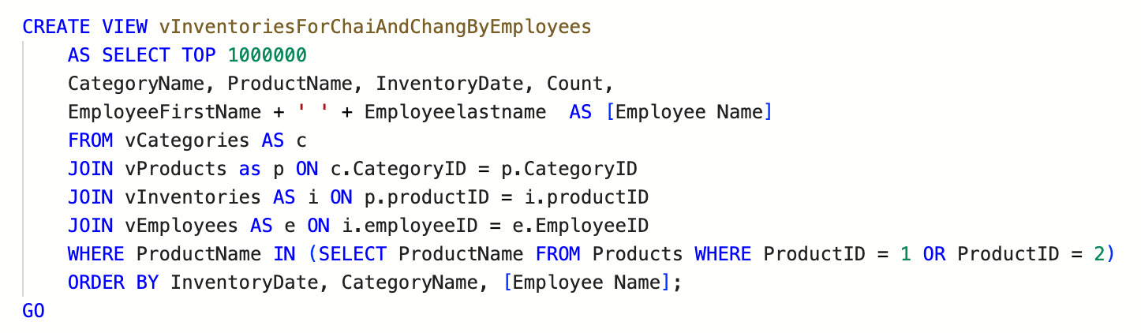

### View, Function, and Stored Procedures

Views allow you to save a select statement and can be helpful when you are joining multiple tables together. A function can return a table of values or it can return a single value. Functions can also create parameters while a View cannot. Stored procedures typically hold more complex code and can be used with INSERT, DELETE, and UPDATE statements. However, you can use all three functions to return a simple table view.

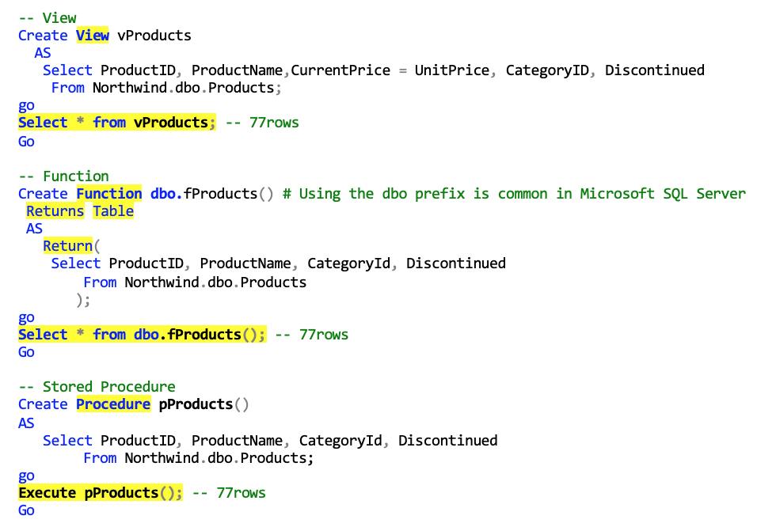

### Summary

In conclusion, SQL views are a way to save a select statement so that you can view your table and not make changes to the actual table. View, function, and stored procedures vary in complexity and all serve a different purpose.